NAME: P. Chandana

EMAIL: [chandanapenumuchu11@gmail.com](mailto:chandanapenumuchu11@gmail.com)

Phone number: 8985597536

Roll Number: 20NN1A12A9

College: Vignan’s Nirula Institute Of Technology And Science For Women

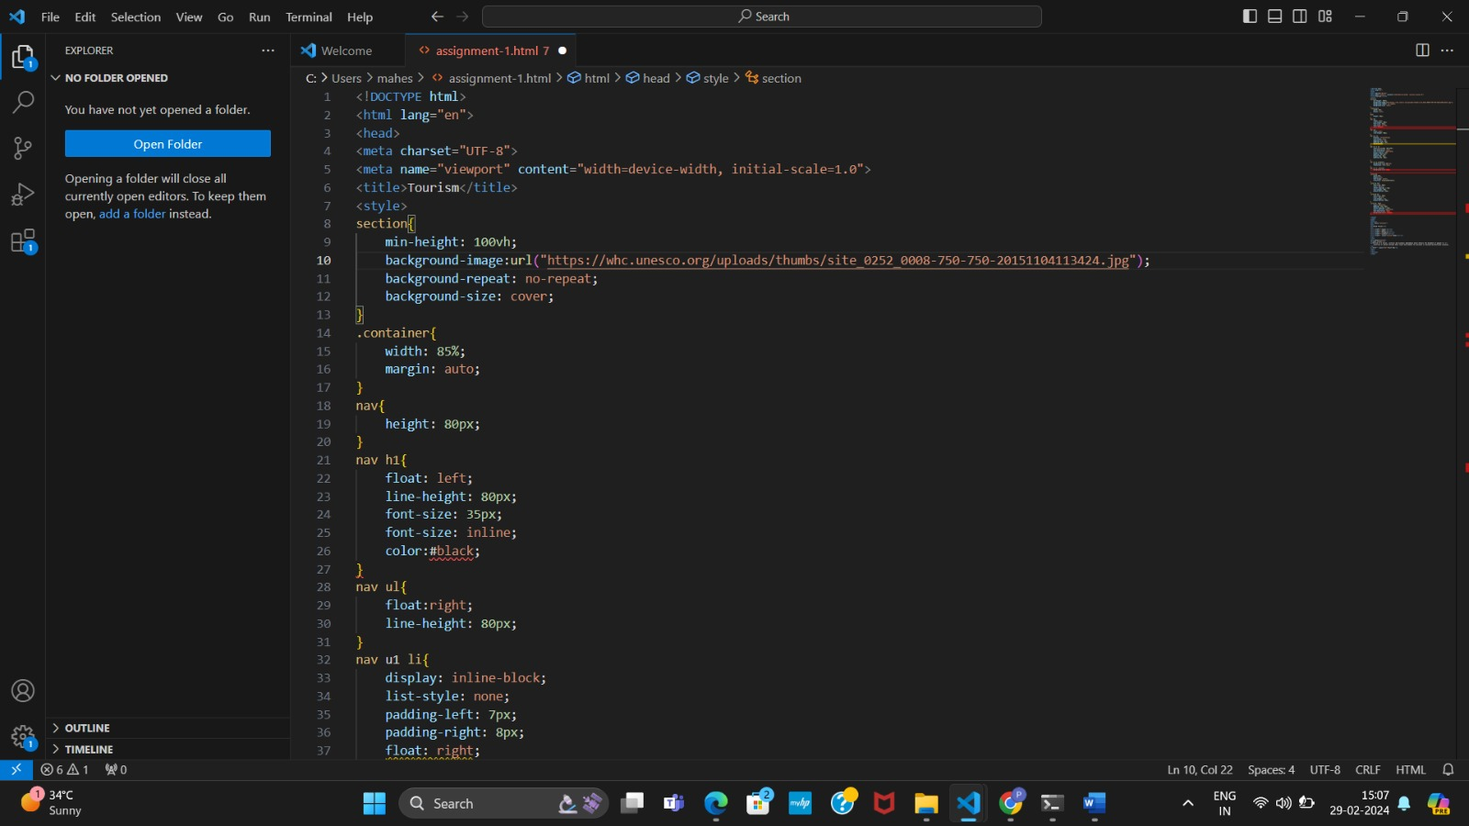

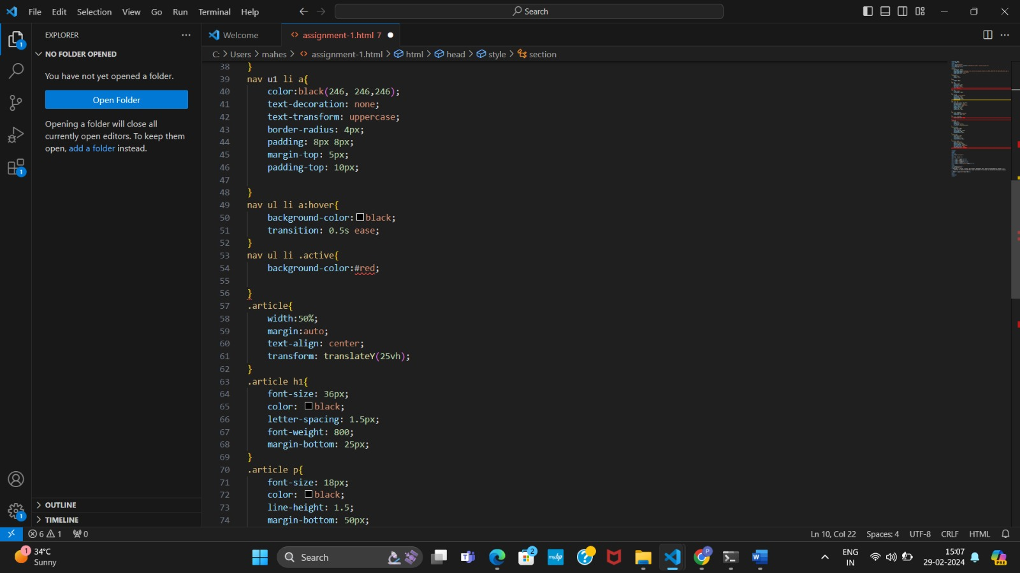;

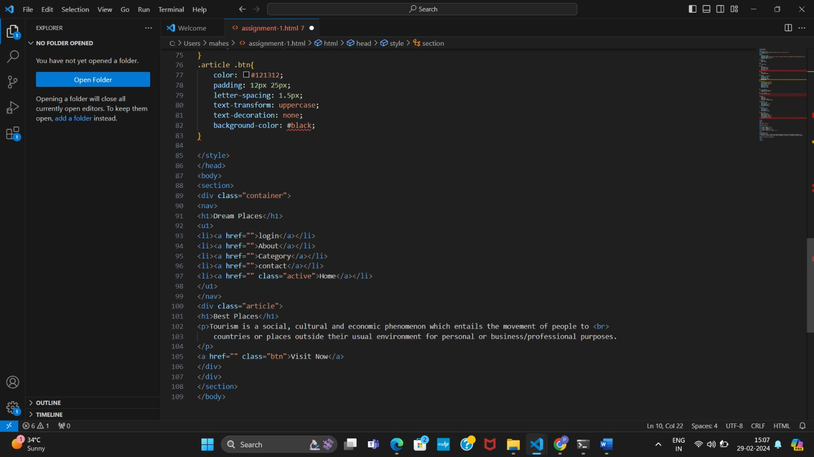

# OUTPUT:-

